National University of Technology



Computer Science Department
Course: HCI and computer graphics Lab
Course Code: CS341
(CS-23-B)
Lab # 02
SUBMITTED TO:
MA’AM RABBIYA YOUNAS

SUBMITTED BY:
Name: MIAN SHAKAR AFZAL
Registration No: F23605073

In Lab Task
Name of the App : Gradely
Designer Name : MIAN SHAKAR AFZAL
Stakeholder Name : ABDUL MATEEN AMIR

- Interview notes
Basic interview questions
 | Questions designed by me [designer] | Answer by the stakeholder
1 | What is the primary goal of this app? | To help students track their grades, attendance, and assignment deadlines.
2 | Who will use this app? | University students and faculty members.
3 | What problems are you currently facing? | Students often miss deadlines and struggle to find consolidated grade reports.
2. Survey
a) Survey Questions (Prepared by Designer):
- Question 1: What features do you consider essential for student success?____________________________
- Question 2: How often do students check their grades?____________________________
- Question 3: Would you prefer a mobile-first or desktop-first design?
b) Responses by Stakeholder:
- Answer to Q1: Grade tracking, assignment reminders, attendance overview. __________________________
- Answer to Q2: At least once a week.
- Answer to Q3: Mobile-first, since students use phones more frequently.

Requirement List (Derived from Stakeholder Demands)
The following table categorizes features into Must-Have and Nice-to-Have requirements, along with the justification for each.
Must-Have Requirements | Nice-to-Have Requirements | Justification /  Rationale
Grade overview dashboard.  Assignment deadline reminders.  Attendance tracker.  Mobile-first responsive UI | Dark mode  Customizable themes.  Motivational quotes or Poetry section.  Faculty chat feature | Grades are core to academic tracking.  Reminders help students stay organized.  Attendance affects eligibility; quotes are for engagement but not essential.  Most users are mobile; chat is useful but can be added later.

Step 3: Design the Must haves + nice to haves [if required] (Designer in Figma)
Designer creates wireframes in Figma for the app , focusing only on features the Stakeholder mentioned.
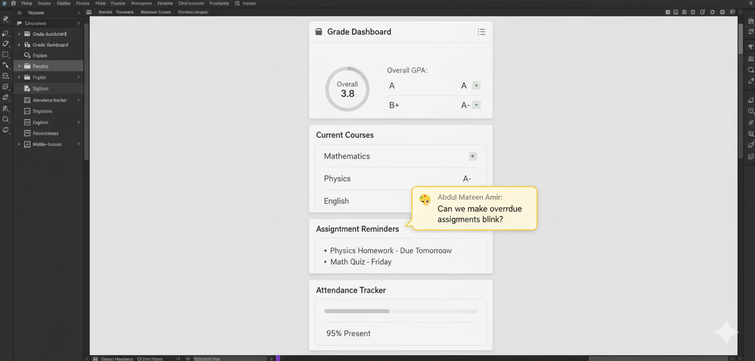
Step 4: Evaluation (Stakeholder + Designer)
Usability Testing Log
Task Tested | Stakeholder Feedback | Designer’s Update in Figma
Checking grades | “The grades are too small and hard to read.” | Increased font size and added bold labels.
Viewing reminders | “Reminders should be color-coded by urgency.” | Added color indicators: red for urgent, green for done.
Attendance screen | “Can we see weekly trends?” | Added a weekly bar graph for attendance.

Step 5: Finalise the design on figma based on the stakeholder’s feedback
- Attach a screenshot of each update
- Fill this table
Designer’s Update in Figma | Complete / incomplete
UPDATES | STATUS
Added a weekly bar graph for attendance. | ✅ Complete
Color-coded reminders | ✅ Complete
Weekly attendance graph | ✅ Complete

COMPLETED.

